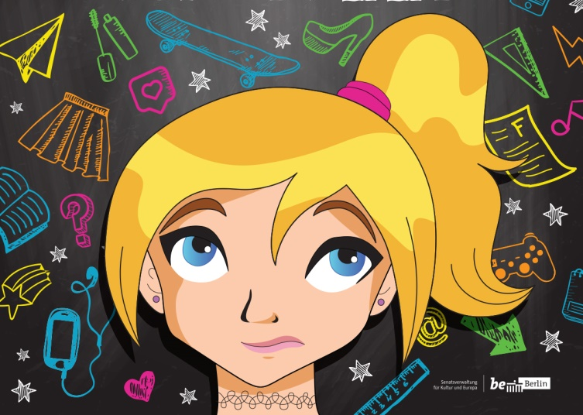
Dear students,
Soon you will be coming to see our play JUST THIRTEEN.
This preparation sheet will help you to understand and enjoy the play better.
The play is about teenagers going through puberty, and the friends and family they drag along for the bumpy ride!

There are three actors in this play:
Julia Burns plays Katy, a thirteen year old girl. She likes her best friend Nicole. She sometimes likes her brother Tyler. But she doesn’t like school.
Benjamin Bishop plays Tyler, Katy’s twin brother. He likes playing video games with his friend Miguel. He also plays his and Katy’s Dad, who sometimes gives his kids good advice. He also plays Ms. Platson, one of Tyler’s teachers.
Olivia Dean plays Nicole, Katy’s best friend forever! She loves Katy. She also likes boys, but she’s not sure which ones. Olivia also plays Miguel, one of the boys Nicole likes. She plays Katy and Tyler’s Mother too, who is trying her best to help her children become teenagers.

Plot:
This play begins the morning of Katy and Tyler’s thirteenth birthday. They are excited to be older but did not expect the difficult parts of being teenagers. They struggle in their friendships with Nicole and Miguel, and do not always see eye to eye with their parents. Does being thirteen make them different people? Katy’s best friend Nicole wants her to participate in the school talent show the talent show, but Katy is not sure if she wants that much attention anymore.

Reviewing these words and phrases used in the play will help you understand it better!
cute | looking sweet | scared | afraid
date | a romantic event | stuff | things/material
disgusting | gross | text | SMS
embarrassing | humiliating | a toast to you | ‘cheers’
emoji | images used in text | hashtag | #
mall | shopping center | best friends forever | strong friendship
fake | not genuine | fit in | be similar to a group
follow | subscribe to someone online | make up with somebody | to end a fight
crop top | a shirt revealing the stomach | profile picture | someone’s photo online, an avatar
lol | laugh out loud | moustache | facial hair above the lip
awesome | great | romantic | demonstrating love
costume | special outfit for performance | to perform | to act out
pimple | a teenager’s blemish on their face | razor | tool used to shave off hair on face or legs
bra | women’s clothing to support breasts | fit together | two people who get along, like a puzzle which fits together
locker | school cupboard for students to keep books | bad/worse/worst | “Peter’s English is bad, Judith’s English is worse, but Emily’s English is the worst of the three.”
blush | rouge  red cheeks from embarrassment

Here is a scene from the play with Katy and her Dad. You can read this with a partner or act it out!
DAD Katy? Katy!
KATY What? What do you want? I‘m going to bed, okay?
DAD Katy. Come here, sit down. Is something wrong? How are you?
KATY I’m okay, Dad.
DAD You are very… emotional these days.
KATY I don‘t know. Everything is really hard right now.
DAD Oh. Are you having trouble at school?
KATY No, it‘s not school. It’s Nicole.
DAD Your best-friend-forever-Nicole?
KATY We are not best friends anymore. She has a boy-friend now, so I am out.
DAD A boy-friend! Really?
KATY Yes.
DAD Do you have a boy-friend?
KATY What, me? No. I will never have a boy-friend.
DAD Well that’s good.
KATY What?
DAD I mean, there’s no hurry. You are only thirteen.
KATY Nicole is thirteen, too.
DAD Oh. Well, it will happen, Katy. Just give it time.
KATY Thanks, Dad. But I don’t want a boy-friend, anyway.
DAD Great. That’s my girl. Just pay attention in school. That’s important.
KATY Uh, right, Dad.
DAD Give me a hug.
KATY Thanks. Good night, Dad.
DAD Good night, Katy.

Now you should be ready to watch the show. Have fun and enjoy JUST THIRTEEN!

