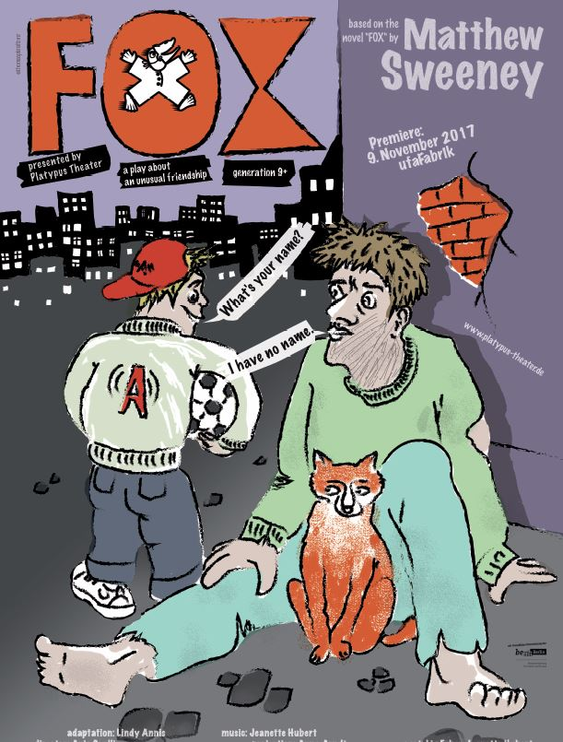
Liebe Schüler und Schülerinnen,

bald kommt ihr zu uns in die Theatervorstellung von FOX. Ihr könnt Euch auf das Stück vorbereiten, z. B. eine Szene lesen und die Vokabeln anschauen und lernen. Keine Angst, ihr werdet das meiste sehr gut verstehen.

Viel Spaß, wir freuen uns auf euren Besuch!

Euer Platypus Theater

*********************************************************************

Plot

Gerard moves with his parents from the country to the city. He is in a new school but he is not very happy there. He dreams of being in a faraway place. Gerard likes to ride his scooter through the new city. He gets to know a homeless man who has a tame fox. Gerard is curious about the man’s way of life - why is the man living on the street, and why does he have a fox? When the man suddenly disappears, Gerard sets out to find him…

There are five actors in the play:

Josh Spriggs plays Gerard, an eleven year old boy. He likes drawing and riding his scooter. He doesn’t like school very much and sometimes loses his temper.

Edvard Lammervo plays a homeless man. He is very poor and begs on the street for money. He has a tame fox named Russ. Edvard also plays a schoolboy named Donny. Donny bullies Gerard.

Ona Nurkkala plays Gerard’s mother. She wants Gerard to be happy in his new school and to make friends. Ona also plays other roles in the play. Ms. Picket, the school teacher, the school student Emmy and a woman named Bubby who is mentally ill.

Marcela Dias plays the fox, Russ, which is a puppet. Marcela also plays the school student Ruby, a beggar named Milly and Nancy, a friend of Gerard’s mother.

Jeanette Hubert plays the part of Sookie, the street musician. She also is responsible for sound effects and live music.

Vocabulary

These words and phrases may be new for you. Try to find the right match!
You can look them up in a dictionary or ask your teacher or your parents or perhaps you have someone in your class whose mother tongue is English.

Word Explanation
a bicycle without a seat, one foot on the scooter, the other foot on the ground
a three sided geometrical figure, also a musical instrument in an orchestra
the round piece of metal through which you throw the basketball to score a goal
a strong feeling you get when you are upset
a design or image made on a surface
you need a piece of paper and a pencil
lots of animals have tails at the back of their bodies, horses, dogs, cats, foxes
vom Weg abkommen
to be close with someone
the colours black and white are different
pay attention
you put this around your neck in winter
a shop in which you buy bread and cakes
a person without a home
money
the central street
Sweets
a physical way of dealing with a problem
when you go out on the street with your dog
not possible, cannot be done
a rodent with grey fur and a long hairless tail larger than a mouse
a useful instrument showing you the directions, east, west, north and south
if you have a fight at school you may get into trouble with the headmaster or headmistress
a place where rubbish is collected, e.g. old chairs, broken washing machines
animals such as foxes, dogs and cats have claws. People have fingernails
eight short arms and two longer tentacles, a long body
a big, dangerous black fish with a fin and very sharp teeth
A place where you can go when you are sick
a pause, free time
meat wrapped in skin, often grilled on a barbecue
a person who takes care of sick people
when I go away on a school camp I miss my mother, my father and brothers and sisters
try to rescue him, to help him out of a dangerous situation
every door has a lock, you put the key in the lock

a triangle
try to save him
Did you miss me?
impossible
a tail
a drawing
angry
get in trouble
lock
to lose one‘s way
claws
nurse
he is different
squid
a scarf
sausage
a scooter or kick bike
garbage dump
a picture
a bakery
jelly babies
a shark
take Russ for a walk

fighting/ to fight/ the boys are fighting
a basketball hoop

a compass
hospital
main street
be careful! Watch out! Take care!
break time or lunch break

to make friends
a rat, rats (pl.)
a homeless person

a pound (money in England is in pounds and pence)

Try to draw a fox! Try to draw a homeless person.

Have you ever seen a fox or a homeless person? Where?

Here is a scene from the play for you to read or act out.

Scene 4
Homeless man, the fox and Gerard on the street.

Gerard Look, I found something! Fifty pence! (gives him a coin)
Man Thank you, son.
Gerard Is that a fox?
Man Yes it is.
Gerard Wow, a real fox! I’ve never seen a fox before. Is he your pet?
Man He’s my friend.
Gerard He looks so soft. Is he soft?
Man Yes, he is.
Gerard How old is he?
Man I don’t know, about 6 years old, I think.
Gerard I see you here a lot, you and the fox. You always sit here.
Man I see you, too.
Gerard You do?
Man Yes, I see you on your kick-bike everyday.
Gerard You do?
Man You go this way, then you go that way.
Gerard That’s right. My school is down there and my house is over there.
Man Yes.
Gerard Where do you live? I mean, do you have a home?
Man I have a place where I sleep.
Gerard But not a house, right?
Man No.
Gerard I’m new here in town.
Man I am old here in town.
Gerard My name is Gerard, Gerard Lavelle.
Man Good.
Gerard Well, goodbye.
Man Goodbye, Gerard Lavelle! (Exit Gerard)

Visit these websites: www.simoncommunity.com
http://blog.zeit.de/kinderzeit/2010/01/21/ein-leben-auf-der-strase_4364

**********************************************************
P.S. If you like, send us a letter or a drawing. Tell us what you liked about the play.

postal address
Platypus Theater
Markgrafenstraße 87
10969 Berlin
www.platypus-theater.de •

email address
mail@platypus-theater.de

